Fusing Census and NCES Data to Identify Socioeconomic Predictors of K-12 Dropout Rates Across U.S. States
CIS 635: Knowledge Discovery and Data Mining | Grand Valley State University | April 2026
Team: Morgan Hamlin, Joshua Cooling (ADD YOUR NAME)
Abstract
(We can revise as code, or project evolves this is a foundation)
Our study investigates whether state-level socioeconomic indicators derived from the U.S. Census Bureau American Community Survey (ACS) can predict K-12 student dropout rates reported by the National Center for Education Statistics (NCES). Using a multimodal data fusion approach, we merged ACS county-level estimates (poverty rate, median household income, and bachelor's degree attainment rate) with NCES Common Core of Data (CCD) district-level dropout and graduation counts, aggregating both datasets to 52 U.S. state-level observations for the 2022-2023 academic year. A linear regression model trained on the three socioeconomic features achieved an R² of 0.19, with bachelor's degree attainment rate (r = 0.32) and poverty rate (r = 0.16) emerging as the strongest correlates. These findings suggest that adult educational attainment in a state is a more salient predictor of youth dropout than income alone, and that heterogeneous government data sources can be meaningfully fused to surface these patterns. We discuss limitations of state-level aggregation and propose district-level fusion via NCES EDGE geographic crosswalks as a promising direction for future work.
1. Introduction & Problem Statement
The United States faces a persistent K-12 dropout crisis with significant economic and social consequences. Students who do not complete high school earn substantially less over their lifetimes, are more likely to experience unemployment, and face higher rates of incarceration compared to graduates. While demographic research has consistently linked socioeconomic conditions to educational outcomes, operationalizing these relationships at scale using publicly available government data remains a challenge for researchers and policymakers alike.
Our project is situated within the broader question of how socioeconomic factors shape graduation and dropout outcomes. A full investigation of this question would require district-level data on poverty, income, parental education, unemployment, urbanity, district size, and regional context. This study addresses two of these questions directly, with the remaining questions deferred to future work pending district-level data fusion.
This project directly addresses the following two research questions:
- Is the poverty rate significantly correlated with K-12 dropout rates at the state level? We test whether counties and states with higher poverty rates produce higher district-level dropout rates after aggregation.
- Does parental education level predict dropout outcomes more strongly than household income? This directly tests whether the community education context outweighs income as a predictor.
The following research questions were identified as important but could not be addressed with the current state-level dataset. They are documented here as a motivation for future work.
- Are rural districts more sensitive to socioeconomic disadvantage than urban districts?
- Are districts with higher unemployment rates more likely to have lower graduation rates?
- Are socioeconomic effects greater in small districts?
- Are there regional differences in graduation rates among states with similar socioeconomic profiles?
Answering research questions one and two required fusing two heterogeneous federal datasets, the Census Bureau’s ACS and the NCES CCD, which present different geographic identifiers like county vs. district, along with different collection methodologies. This data fusion challenge was the core contribution of our work, which mirrors real-world barriers that prevent education researchers from leveraging the full capabilities of available public data.
2. Related Work
(Each of us adds how this relates to your research topic from phase 1, include your reference at bottom of paper)
3. Methodology
3.1 Data Sources
We used two primary data sources:
- Census AC 5-Year Estimates (2023): Retrieved via the Census Bureau API at the county level (n=3,222 countries). Variables extracted: poverty rate (S1707), median household income (S1901), and bachelor’s degree attainment rate (S1501).
- NCES Common Core of Data (2022-2023): Three district-level files downloaded from nces.ed.gov
3.2 Data Fusion Pipeline
The primary challenge was the mismatch between Census data (county level) and NCES data (school district level). NCES district files do not contain county FIPS codes, preventing a direct county-to-district join. We resolved this by aggregating both datasets to the state level using the two-digit state FIPS code (FIPST) as the shared merge key, yielding 52 observations (50 states + DC + one territory).
The pipeline consisted of the following steps:
- NCES Cleaning:
- State Aggregation:
- Fusion:
- Additional Computing:
3.3 Modeling
We trained a multiple linear regression model (scikit-learn LinearRegression) using three features: poverty_rate, median_income, and bachelor_plus_rate. The target variable was dropout_rate. No train/test split was applied given the small sample size (n = 52); instead, we report in-sample R² as a measure of explanatory power and discuss this limitation in Section 5.
4. Experiments & Results
4.1 Descriptive Statistics

Variable | Mean | Std Dev | Min | Max
Poverty Rate (%) | 14.10 | 5.43 | 8.62 | 44.69
Median Income ($) | 68,308 | 15,010 | 22,431 | 106,287
Bachelor's Degree Rate (%) | 27.42 | 8.45 | 17.61 | 63.60
Dropout Rate (%) | 12.44 | 5.92 | 4.96 | 39.22
Table 1: Descriptive statistic for fused state-level dataset.
4.2 Correlation Analysis

4.3 Regression Results
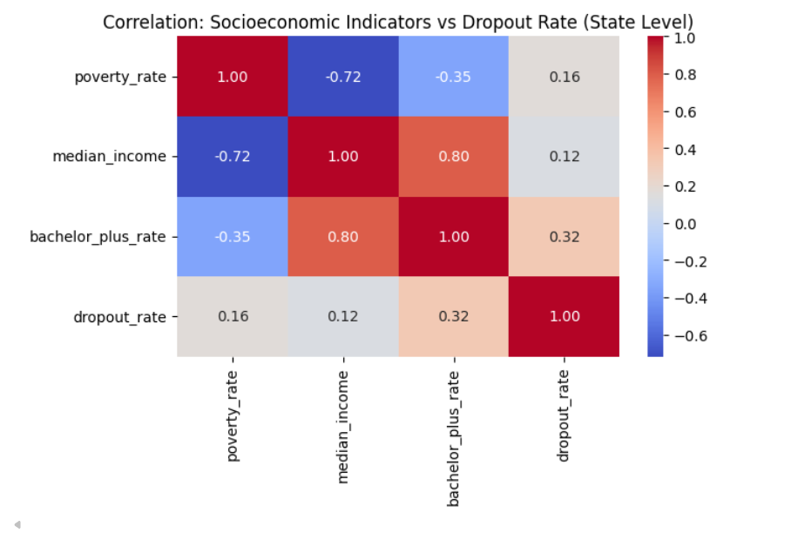
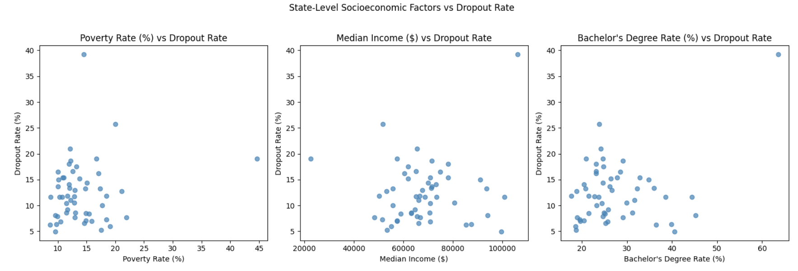
5. Discussion & Limitations
6. Conclusion & Future Work
References
Almeda, M. V., et al. (2024). Systematic Literature Review on Explainable Learning Analytics and Educational Data Mining. ResearchGate. https://www.researchgate.net/publication/398645869
U.S. Census Bureau. (2023). Educational Attainment (S1501). American Community Survey 5-Year Estimates. https://data.census.gov/table/ACSST5Y2023.S1501
U.S. Census Bureau. (2023). Poverty Status in the Past 12 Months (S1701). American Community Survey 5-Year Estimates. https://data.census.gov
National Center for Education Statistics. (2023). Common Core of Data: Local Education Agency Universe Survey (2022-2023). https://nces.ed.gov/ccd/files.asp
KDD 2025 Applied Data Science Track. https://kdd2025.kdd.org/applied-data-science-ads-track-papers-2/

